GREATER CAIRO METRO
LINE No.3 (Thawra Line)
TCMS-AAU interface specification

Approved by | 03.Apr.2019 | K.K. SHIN | 
Reviewed by | 03.Apr.2019 | S.J. SEO | 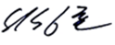
Written by | 03.Apr.2019 | H.KIM | 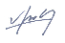
 | Date | Name | Signature

Revision History
Issue | Page | Revision |  | Date
Issue | Page | Contents | Reference | Date
0 | All | First issue |  | 03.Apr.2019

Contents
1. INTRODUCTION 4
1.1. LIST OF ABBREVIATIONS 4
2. GENERAL 5
2.1. MVB Specification 5
2.2. MVB Connection 6
2.3. MVB Telegram 6
2.4. Train Formation of Cairo3 8
3. DATA EXCHANGE 10
3.1. TCMS → AAU SDR (Status Data Request) 10
3.1.1. TCMS-FDU-SDR 10
3.2. AAU → TCMS SD(Status Data) 13
3.2.1. AAU-TCMS-SD 13

INTRODUCTION
This document describes the interface specification between TCMS(Train Control and Monitoring System) and AAU(Fire Automatic Announcement Unit) for GREATER CAIRO METRO LINE No.3 (Thawra Line) project.

LIST OF ABBREVIATIONS
TCN Train Control Network
MVB Multifunction Vehicle Bus
EMD Electrical Medium Distance
WTB Wire Train Bus
TCMS Train Control and Monitoring System
CCU Central Control Unit
VCU Vehicle Control Unit
IO-M remote IO Module
VVVF Variable Voltage Variable Frequency
DU Display Unit
RTD Remote Transmission Device
DCU Door Control Unit
ATP Automatic Train Protection
EBCU Electrical Brake Control Unit
VAC Ventilation Air conditioner Controller
TCU Traction Control Unit
APU Auxiliary Power Unit
EVR Event Recorder
HCR Header Car Relay
MF Major Fault
MCF Major Complementary Fault
HSCB High Speed Circuit Breaker
LB Line Bus Switch
PB Parking Brake
EB Emergency Brake
HB Holding Brake
FSB Full Service Brake
AUTO Automatic Mode
ADB All Door Bypass
ADC All Door Closed
AAU Automatic Announcement Unit
DCU Display Control Unit(for PA/PIS)
BC Battery Charger
HCR Head Control Relay
SDR Status Data Request
SD Status Data

GENERAL

MVB Specification
General specification of MVB is described as follow.
-. Redundancy : Line A, Line B
-. Master / Slave : TCMS is only Master.
The subsystem needs not to act as bus administrator.
-. Media Support : EMD(Electrical Middle Distance) Communication Distance within 200m
<Table 1 Summary of the Multifunction Vehicle Bus by IEC 61375-1>
topology | bus(electrical)  star(optical)
Media | Electrical Short Distance  Electrical Middle Distance  Optical Glass Fibre | twisted wire pair, biased RS-485  shielded twisted wire pair, transformer coupled  200/240 µm fibres and star coupler
Length | Electrical Short Distance  Electrical Middle Distance  Optical Glass Fibre | 20 m, 32 devices per segment  200 m, 32 devices per segment  2000 m
Physical Redundancy | duplicated physical medium(synchronous send)
Signalling | Manchester II, 9-bit frame Start Delimiter
Signalling rate | 1.5 Mbit/s
Address space | 12-bit Device Address  (0…255 reserved for devices with Message Data capability)  12-bit Logical Address for Process Data  (each 16…256 bits)
Physical Addressing | single cast and broadcast
Frame size  (useful data) | 16, 32, 64, 128, 256 bits
Integrity | CRC-8 per 64bits + Manchester encoding, different frame Start Delimiter for Master Frame and Slave Frame against synchronization slip, reception time window supervision
Medium Allocation | by one centralized Master(Hyundai-Rotem’s CCU & VCU)
Traffic | periodic(mainly for Process Data)  sporadic(mainly for Message Data)  supervisory(for Supervisory Data)
Mastership Transfer | mastership transfer by token passing  serveral Bus Administrators can become Master in turn
Mastership Redundancy  (Option) | redundant Bus Administrators serve as back-up
Link Layer Service | Link Process Data Interface  Link Message Data Interface  Link Supervision Interface |  | broadcast of source addressed data  datagrams  Link Layer Management

MVB Connection
Where interchangeability is required, Subsystems connected by MVB shall be attached to the cable as follow:
<Table 2 Pin assignment for the EMD Connector>
1 | A.Data_P positive wire of Line A | 6 | A.Term_P, Positive pole of Terminator Line A
2 | A.Data_N negative wire of Line A | 7 | A.Term_N, Negative pole of Terminator Line A
3 | Not Used | 8 | B.Term_P, Positive pole of Terminator Line B
4 | B.Data_P positive wire of Line B | 9 | B.Term_N, Negative pole of Terminator Line B
5 | B.Data_N negative wire of Line B
Note 1 It is recommend to arrange the two connectors side by side on a device, Connector 1 on the left and Connector 2 on the right, to thread the wiring neatly.
Note 2 It may be necessary to ensure that the connector case is isolated from the device case if connection of the device cases is not advisable, for instance when large stray currents are expected.
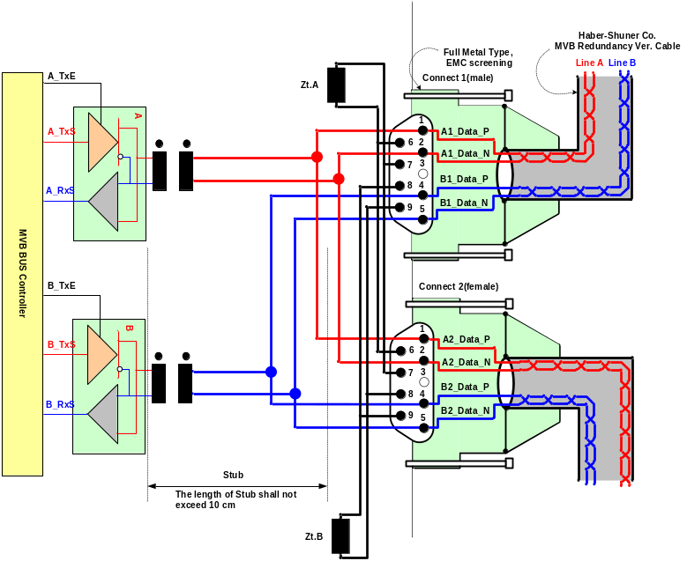
Figure 1 Double line EMD connector arrangement

MVB Telegram
There are 16 telegrams types on the MVB, which are distinguished by the F-code in Master Frame, as shown in Table 3.
Table 3 F-code of the MVB(Master Frame Type)

F-Code | Telegram Type
0 | Process Data Request with 16 bits
1 | Process Data Request with 32 bits
2 | Process Data Request with 64 bits
3 | Process Data Request with 128 bits
4 | Process Data Request with 256 bits
5 | (reserved)
6 | (reserved)
7 | (reserved)
8 | Mastership Transfer Request
9 | General Event Request
10 | (reserved)
11 | (reserved)
12 | Message Data Request
13 | Group Event Request
14 | Single Event Request
15 | Device Status Request
The basic data type for MVB network between TCMS and sub-system is WORD. Physical address is not used.
The byte ordering is the Big-Endian(Motorola) but, all data is read like word. So, the subsystem side must change like example.
The byte order and bit order for a data are as follows.
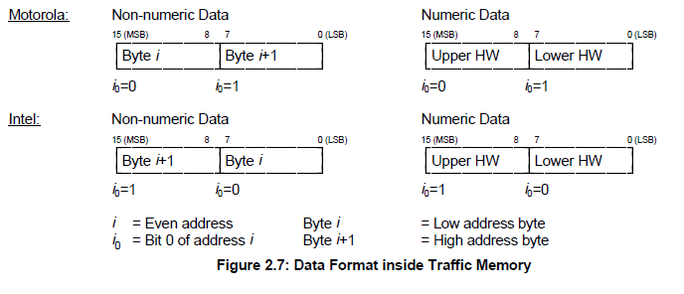
- MVB supervision :
The CCU is indicating the MVB state by the MVB watchdog counter that increases when the application is executed.
The counter from the MVB device is generated as soon as the application software is ready. If no MVB connection is established, i.e.
The MVB watchdog counter can not be received or an internal fault in the MVB device occurs, the signals, besides the watchdog counter, shall be had default value.
<Bit Ordering>
Data structures shall be numbered from left to right and from top to bottom, in the order of reading an English text. The first item on the top and to the left has offset zero.
WORD | Data Contents |  |  |  |  |  |  |  | Remark
WORD | Bit Mask |  |  |  |  |  |  |  | Remark
WORD | 15 | 14 | 13 | 12 | 11 | 10 | 9 | 8
WORD | 7 | 6 | 5 | 4 | 3 | 2 | 1 | 0
0 | 0 | 1 | 2 | 3 | 4 | 5 | 6 | 7
0 | 8 | 9 | 10 | 11 | 12 | 13 | 14 | 15
1 | 16 | 17 | 18 | 19 | 20 | 21 | 22 | 23
1 | 24 | 25 | 26 | 27 | 28 | 29 | 30 | 31
2 | 32 | 33 | 34 | 35 | 36 | 37 | 38 | 39
2 | 40 | 41 | 42 | 43 | 44 | 45 | 46 | 47
3 | 48 | 49 | 50 | 51 | 52 | 53 | 54 | 55
3 | 56 | 57 | 58 | 59 | 60 | 61 | 62 | 63
4 | 64 | 65 | 66 | 67 | 68 | 69 | 70 | 71
4 | 72 | 73 | 74 | 75 | 76 | 77 | 78 | 79
5 | 80 | 81 | 82 | 83 | 84 | 85 | 86 | 87
5 | 88 | 89 | 90 | 91 | 92 | 93 | 94 | 95
6 | 96 | 97 | 98 | 99 | 100 | 101 | 102 | 103
6 | 104 | 105 | 106 | 107 | 108 | 109 | 110 | 111
7 | 112 | 113 | 114 | 115 | 116 | 117 | 118 | 119
7 | 120 | 121 | 122 | 123 | 124 | 125 | 126 | 127
8 | 128 | 129 | 130 | 131 | 132 | 133 | 134 | 135
8 | 136 | 137 | 138 | 139 | 140 | 141 | 142 | 143
9 | 144 | 145 | 146 | 147 | 148 | 149 | 150 | 151
9 | 152 | 153 | 154 | 155 | 156 | 157 | 158 | 159
10 | 160 | 161 | 162 | 163 | 164 | 165 | 166 | 167
10 | 168 | 169 | 170 | 171 | 172 | 173 | 174 | 175
11 | 176 | 177 | 178 | 179 | 180 | 181 | 182 | 183
11 | 184 | 185 | 186 | 187 | 188 | 189 | 190 | 191
12 | 192 | 193 | 194 | 195 | 196 | 197 | 198 | 199
12 | 200 | 201 | 202 | 203 | 204 | 205 | 206 | 207
13 | 208 | 209 | 210 | 211 | 212 | 213 | 214 | 215
13 | 216 | 217 | 218 | 219 | 220 | 221 | 222 | 223
14 | 224 | 225 | 226 | 227 | 228 | 229 | 230 | 231
14 | 232 | 233 | 234 | 235 | 236 | 237 | 238 | 239
15 | 240 | 241 | 242 | 243 | 244 | 245 | 246 | 247
15 | 248 | 249 | 250 | 251 | 252 | 253 | 254 | 255

Train Formation of Cairo3
The train formation consists of 8 cars and can be seen in following figure. The detail arrangement is DTC-MC1-MC2-MCI-MCI-MC2-MC1-DTC. The two CCUs(Central Control Unit) are installed in both DTC, two VCUs are installed in MCI and two IO-Ms are installed in MC. CCU and VCU(Vehicle Control Unit) is connected to subsystem via MVB(Multifunction Vehicle Bus), WTB(Wire Train Bus) is used by the data communication interface between CCU and VCU.

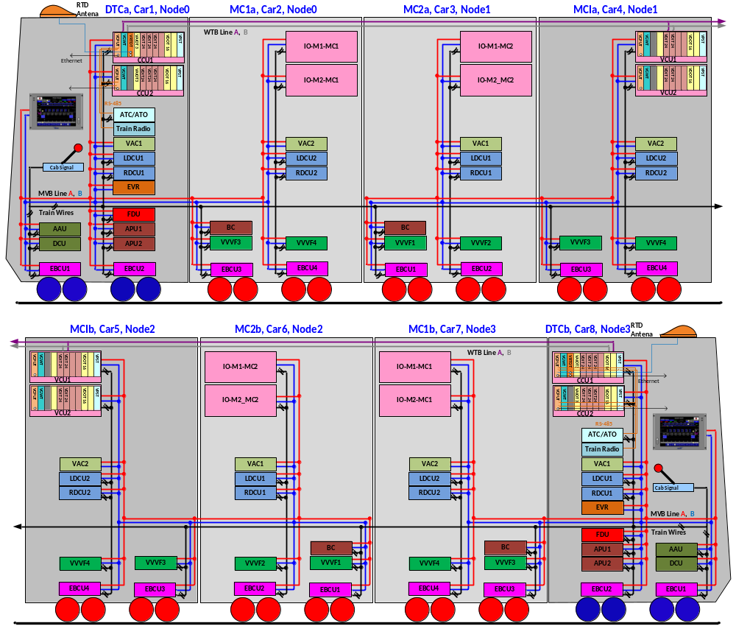

Figure 2 Configuration

DATA EXCHANGE

TCMS → AAU SDR (Status Data Request)
Telegram name | Source | Sink | Port address | Fcode | Task | Remark
TCMS-AAU-SDR | TCMS | AAU | 0x110 | 4

TCMS-FDU-SDR
WORD | Data Contents |  |  |  |  |  |  |  | Remark
WORD | Bit Mask |  |  |  |  |  |  |  | Remark
WORD | 15 | 14 | 13 | 12 | 11 | 10 | 9 | 8
WORD | 7 | 6 | 5 | 4 | 3 | 2 | 1 | 0
0 | WatchDogCounterTCMS
1 | DateTimeYear
1 | DateTimeMonth
2 | DateTimeDay
2 | DateTimeHour
3 | DateTimeMinute
3 | DateTimeSec
4 | DateTimeValid |  |  |  | MVB_Node3(car7/8) | MVB_Node2(car5/6) | MVB_Node1(car3/4) | MVB_Node0(car1/2)
4 |  |  |  |  | AllDoorClosed | ZVR | HCR | TCR
5 | Station identification number(See “Appendix: Station identification” for station number) |  |  |  |  |  |  |  | ATC
5 | Train Speed(km/h) 1= 1km/h
6 | Train_Number(BCD X000) |  |  |  | Train_Number(BCD 0X00) |  |  |  | For Up/Down
6 | Train_Number(BCD 00X0) |  |  |  | Train_Number(BCD 000X)
7 | Start_Distance[m]
8 | Salon alarm request
8 | CAB alarm request
9
10
11
12
13
14
15

Bit  Offset | Data  Size | Data  Type | Data Name | Contents | Remarks
0 | 16 | UNSIGNED16 | TWatchDogCounterTCMS
16 | 8 | UNSIGNED8 | DateTimeYear | Year (00 – 99), | BCD
24 | 8 | UNSIGNED8 | DateTimeMonth | Month (1 – 12) | BCD
32 | 8 | UNSIGNED8 | DateTimeDay | Day (1 – 31) | BCD
40 | 8 | UNSIGNED8 | DateTimeHour | Hour (0 -23) | BCD
48 | 8 | UNSIGNED8 | DateTimeMinute | Minute (0 – 59) | BCD
56 | 8 | UNSIGNED8 | DateTimeSec | Second (0 – 59) | BCD
64 | 1 | BOOL | DateTimeValid | 0/1, 1 = Date & Time Validation
65 | 1 | BOOL
66 | 1 | BOOL
67 | 1 | BOOL
68 | 1 | BOOL | MVB_Node3(car7/8) | MVB NODE3 position(Refer to Fig2)
69 | 1 | BOOL | MVB_Node2(car5/6) | MVB NODE2 position(Refer to Fig2)
70 | 1 | BOOL | MVB_Node1(car3/4) | MVB NODE1 position(Refer to Fig2)
71 | 1 | BOOL | MVB_Node0(car1/2) | MVB NODE0 position(Refer to Fig2)
72 | 1 | BOOL
73 | 1 | BOOL
74 | 1 | BOOL
75 | 1 | BOOL
76 | 1 | BOOL | AllDoorClosed | 1 = All door closed
77 | 1 | BOOL | ZVR | 1 = ZVR
78 | 1 | BOOL | HCR | 1 = HCR(Head Car Relay On)
79 | 1 | BOOL | TCR | 1 = TCR(Tail Car Relay On)
80 | 8 | UNSIGNED8 | Station identification number | (See “Appendix: Station identification” for station number)  Example :  ATTABA track 2 UP = 0 010 001 0  Train is delocalised = 0 000 000 0
88 | 8 | UNSIGNED8 | Train Speed((km/h)) | 1= 1km/h
96 | 8 | UNSIGNED8 | Train_Number | Train Number(BCD XX00)
104 | 8 | UNSIGNED8 | Train_Number | Train Number(BCD 00XX)
112 | 16 | UNSIGNED16 | Start_Distance[m] | Start Distance is TCMS calculation distance from start station position(door open)
128 | 8 | UNSIGNED8 | Salon alarm request | -. Play prerecorded alarm sound to passenger salon (by RSPK)  -. Have Lower priority then OCC and manual announcement.  -. Lower bit have higher priority (play only once when data is set to 1)
136 | 8 | UNSIGNED8 | CAB alarm request | -. Play prerecorded alarm sound to driving CAB (by MSPK)  -. Lower bit have higher priority (continue playing while data is set to 1)

<APPENDIX: Station identification>
UP Direction is from HISHAM BARAKAT to ATTABA and for workshop exit
DOWN direction is from ATTABA to HISHAM BARAKAT and for workshop entry.
Station Name  (Track) | UP | DOWN
HISHAM BARAKAT Post Station Platform (Track 1) | 1 000 010 0 | 1 000 010 1
HISHAM BARAKAT Post Station Platform (Track 2) | 0 000 010 0 | 0 000 010 1
HISHAM BARAKAT (Track 1) | 1 000 011 0 | 1 000 011 1
HISHAM BARAKAT (Track 2) | 0 000 011 0 | 0 000 011 1
EL NOZHA (Track 1) | 1 000 100 0 | 1 000 100 1
EL NOZHA (Track 2) | 0 000 100 0 | 0 000 100 1
EL SHAMS CLUB (Track 1) | 1 000 101 0 | 1 000 101 1
EL SHAMS CLUB (Track 2) | 0 000 101 0 | 0 000 101 1
ALF MASKEN (Track 1) | 1 000 110 0 | 1 000 110 1
ALF MASKEN (Track 2) | 0 000 110 0 | 0 000 110 1
HELIOPOLIS SQUARE (Track 1) | 1 000 111 0 | 1 000 111 1
HELIOPOLIS SQUARE (Track 2) | 0 000 111 0 | 0 000 111 1
HAROUN (Track 1) | 1 000 001 0 | 1 000 001 1
HAROUN (Track 2) | 0 000 001 0 | 0 000 001 1
AL AHRAM (Track 1) | 1 001 001 0 | 1 001 001 1
AL AHRAM (Track 2) | 0 001 001 0 | 0 001 001 1
KOLLEYET EL BANAT (Track 1) | 1 001 010 0 | 1 001 010 1
KOLLEYET EL BANAT (Track 2) | 0 001 010 0 | 0 001 010 1
STADIUM (Track 1) | 1 001 011 0 | 1 001 011 1
STADIUM (Track 2) | 0 001 011 0 | 0 001 011 1
CAIRO FAIR (Track 1) | 1 001 100 0 | 1 001 100 1
CAIRO FAIR (Track 2) | 0 001 100 0 | 0 001 100 1
ABBASIA (Track 1) | 1 001 101 0 | 1 001 101 1
ABBASIA (Track 2) | 0 001 101 0 | 0 001 101 1
ABBASIA (Track 3) | 1 111 111 0 | 1 111 111 1
ABBASIA Track Circuit T771 (Track 7) | 1 111 110 0 | 1 111 110 1
ABBASIA Track Circuit T773 (Track 7) | 1 111 101 0 | 1 111 101 1
ABBASIA Workshop Access Track T753A | 0 111 111 0
ABBASIA Workshop Access Track T759 |  | 0 111 111 1
ABDOU PASHA (Track 1) | 1 001 110 0 | 1 001 110 1
ABDOU PASHA (Track 2) | 0 001 110 0 | 0 001 110 1
EL GEISH (Track 1) | 1 001 111 0 | 1 001 111 1
EL GEISH (Track 2) | 0 001 111 0 | 0 001 111 1
BAB EL SHAARIA (Track 1) | 1 010 000 0 | 1 010 000 1
BAB EL SHAARIA (Track 2) | 0 010 000 0 | 0 010 000 1
ATTABA (Track 2) | 0 010 001 0 | 0 010 001 1

AAU → TCMS SD(Status Data)
Telegram name | Source | Sink | Port address | Fcode | Task | Remark
AAU-TCMS-SD | AAU | TCMS | 0x110 | 4

AAU-TCMS-SD
WORD | Data Contents |  |  |  |  |  |  |  | Remark
WORD | Bit Mask |  |  |  |  |  |  |  | Remark
WORD | 15 | 14 | 13 | 12 | 11 | 10 | 9 | 8
WORD | 7 | 6 | 5 | 4 | 3 | 2 | 1 | 0
0 | AAU Watchdog Counter (0~65535)
1 | Destination station ID
2 | Next station ID
3
4 | AAU Fault  (Car1) | COU Fault  (Car1) | SOU_L Fault  (Car1) | SOU_R Fault  (Car1) | AAU Fault  (Car8) | COU Fault  (Car8) | SOU_L Fault  (Car8) | SOU_R Fault  (Car8)
4 |  |  |  |  |  |  |  | PEI NAK
5 | PEI_1 Fault | PEI_2 Fault | PEI_3 Fault | PEI_4 Fault | PAMP Fault |  |  |  | Car1
5 | PEI_1 Call | PEI_2 Call | PEI_3 Call | PEI_4 Call |  |  |  |  | Car1
6 | PEI_1 Fault | PEI_2 Fault | PEI_3 Fault | PEI_4 Fault | PAMP Fault |  |  |  | Car2
6 | PEI_1 Call | PEI_2 Call | PEI_3 Call | PEI_4 Call |  |  |  |  | Car2
7 | PEI_1 Fault | PEI_2 Fault | PEI_3 Fault | PEI_4 Fault | PAMP Fault |  |  |  | Car3
7 | PEI_1 Call | PEI_2 Call | PEI_3 Call | PEI_4 Call |  |  |  |  | Car3
8 | PEI_1 Fault | PEI_2 Fault | PEI_3 Fault | PEI_4 Fault | PAMP Fault |  |  |  | Car4
8 | PEI_1 Call | PEI_2 Call | PEI_3 Call | PEI_4 Call |  |  |  |  | Car4
9 | PEI_1 Fault | PEI_2 Fault | PEI_3 Fault | PEI_4 Fault | PAMP Fault |  |  |  | Car5
9 | PEI_1 Call | PEI_2 Call | PEI_3 Call | PEI_4 Call |  |  |  |  | Car5
10 | PEI_1 Fault | PEI_2 Fault | PEI_3 Fault | PEI_4 Fault | PAMP Fault |  |  |  | Car6
10 | PEI_1 Call | PEI_2 Call | PEI_3 Call | PEI_4 Call |  |  |  |  | Car6
11 | PEI_1 Fault | PEI_2 Fault | PEI_3 Fault | PEI_4 Fault | PAMP Fault |  |  |  | Car7
11 | PEI_1 Call | PEI_2 Call | PEI_3 Call | PEI_4 Call |  |  |  |  | Car7
12 | PEI_1 Fault | PEI_2 Fault | PEI_3 Fault | PEI_4 Fault | PAMP Fault |  |  |  | Car8
12 | PEI_1 Call | PEI_2 Call | PEI_3 Call | PEI_4 Call |  |  |  |  | Car8
13
14
15 | Ver. Major
15 | Ver. Minor

Bit  Offset | Data  Size | Data  Type | Data Name | Contents | Remarks
0 | 16 | UNSIGNED16 | AAU_WatchdogCounter | -. Range: 0 to 65535 (00h to FFFFh)  -. AAU increments this bit every transmission cycle. TCMS ignores the information of SD if this counter is not incremented for more than "1000ms".
16 | 16 | UNSIGNED16 | Destination station ID | -. Range: 0 to 65535 (00h to FFFFh)  -. Destination station ID of this run | PA setting
32 | 16 | UNSIGNED16 | Next station ID | -. Range: 0 to 65535 (00h to FFFFh)  -. Next stop station ID | PA setting
64 | 1 | BOOL | AAU Fault (Car1) | -. 1 = Fault
65 | 1 | BOOL | COU Fault (Car1) | -. 1 = Fault
66 | 1 | BOOL | SOU_L Fault (Car1) | -. 1 = Fault
67 | 1 | BOOL | SOU_R Fault (Car1) | -. 1 = Fault
68 | 1 | BOOL | AAU Fault (Car8) | -. 1 = Fault
69 | 1 | BOOL | COU Fault (Car8) | -. 1 = Fault
70 | 1 | BOOL | SOU_L Fault (Car8) | -. 1 = Fault
71 | 1 | BOOL | SOU_R Fault (Car8) | -. 1 = Fault
79 | 1 | BOOL | PEI NAK | -. 1 = No response  -. No response to PEI Call
80 | 1 | BOOL | PEI_1 Fault (Car1) | -. 1 = Fault
81 | 1 | BOOL | PEI_2 Fault (Car1) | -. 1 = Fault
82 | 1 | BOOL | PEI_3 Fault (Car1) | -. 1 = Fault
83 | 1 | BOOL | PEI_4 Fault (Car1) | -. 1 = Fault
84 | 1 | BOOL | PAMP Fault (Car1) | -. 1 = Fault
88 | 1 | BOOL | PEI_1 Call (Car1) | -. 1 = Call
89 | 1 | BOOL | PEI_2 Call (Car1) | -. 1 = Call
90 | 1 | BOOL | PEI_3 Call (Car1) | -. 1 = Call
91 | 1 | BOOL | PEI_4 Call (Car1) | -. 1 = Call
96 | 1 | BOOL | PEI_1 Fault (Car2) | -. 1 = Fault
97 | 1 | BOOL | PEI_2 Fault (Car2) | -. 1 = Fault
98 | 1 | BOOL | PEI_3 Fault (Car2) | -. 1 = Fault
99 | 1 | BOOL | PEI_4 Fault (Car2) | -. 1 = Fault
100 | 1 | BOOL | PAMP Fault (Car2) | -. 1 = Fault
104 | 1 | BOOL | PEI_1 Call (Car2) | -. 1 = Call
105 | 1 | BOOL | PEI_2 Call (Car2) | -. 1 = Call
106 | 1 | BOOL | PEI_3 Call (Car2) | -. 1 = Call
107 | 1 | BOOL | PEI_4 Call (Car2) | -. 1 = Call
112 | 1 | BOOL | PEI_1 Fault (Car3) | -. 1 = Fault
113 | 1 | BOOL | PEI_2 Fault (Car3) | -. 1 = Fault
114 | 1 | BOOL | PEI_3 Fault (Car3) | -. 1 = Fault
115 | 1 | BOOL | PEI_4 Fault (Car3) | -. 1 = Fault
116 | 1 | BOOL | PAMP Fault (Car3) | -. 1 = Fault
120 | 1 | BOOL | PEI_1 Call (Car3) | -. 1 = Call
121 | 1 | BOOL | PEI_2 Call (Car3) | -. 1 = Call
122 | 1 | BOOL | PEI_3 Call (Car3) | -. 1 = Call
123 | 1 | BOOL | PEI_4 Call (Car3) | -. 1 = Call
128 | 1 | BOOL | PEI_1 Fault (Car4) | -. 1 = Fault
129 | 1 | BOOL | PEI_2 Fault (Car4) | -. 1 = Fault
130 | 1 | BOOL | PEI_3 Fault (Car4) | -. 1 = Fault
131 | 1 | BOOL | PEI_4 Fault (Car4) | -. 1 = Fault
132 | 1 | BOOL | PAMP Fault (Car4) | -. 1 = Fault
136 | 1 | BOOL | PEI_1 Call (Car4) | -. 1 = Call
137 | 1 | BOOL | PEI_2 Call (Car4) | -. 1 = Call
138 | 1 | BOOL | PEI_3 Call (Car4) | -. 1 = Call
139 | 1 | BOOL | PEI_4 Call (Car4) | -. 1 = Call
144 | 1 | BOOL | PEI_1 Fault (Car5) | -. 1 = Fault
145 | 1 | BOOL | PEI_2 Fault (Car5) | -. 1 = Fault
146 | 1 | BOOL | PEI_3 Fault (Car5) | -. 1 = Fault
147 | 1 | BOOL | PEI_4 Fault (Car5) | -. 1 = Fault
148 | 1 | BOOL | PAMP Fault (Car5) | -. 1 = Fault
152 | 1 | BOOL | PEI_1 Call (Car5) | -. 1 = Call
153 | 1 | BOOL | PEI_2 Call (Car5) | -. 1 = Call
154 | 1 | BOOL | PEI_3 Call (Car5) | -. 1 = Call
155 | 1 | BOOL | PEI_4 Call (Car5) | -. 1 = Call
160 | 1 | BOOL | PEI_1 Fault (Car6) | -. 1 = Fault
161 | 1 | BOOL | PEI_2 Fault (Car6) | -. 1 = Fault
162 | 1 | BOOL | PEI_3 Fault (Car6) | -. 1 = Fault
163 | 1 | BOOL | PEI_4 Fault (Car6) | -. 1 = Fault
164 | 1 | BOOL | PAMP Fault (Car6) | -. 1 = Fault
168 | 1 | BOOL | PEI_1 Call (Car6) | -. 1 = Call
169 | 1 | BOOL | PEI_2 Call (Car6) | -. 1 = Call
170 | 1 | BOOL | PEI_3 Call (Car6) | -. 1 = Call
171 | 1 | BOOL | PEI_4 Call (Car6) | -. 1 = Call
176 | 1 | BOOL | PEI_1 Fault (Car7) | -. 1 = Fault
177 | 1 | BOOL | PEI_2 Fault (Car7) | -. 1 = Fault
178 | 1 | BOOL | PEI_3 Fault (Car7) | -. 1 = Fault
179 | 1 | BOOL | PEI_4 Fault (Car7) | -. 1 = Fault
180 | 1 | BOOL | PAMP Fault (Car7) | -. 1 = Fault
184 | 1 | BOOL | PEI_1 Call (Car7) | -. 1 = Call
185 | 1 | BOOL | PEI_2 Call (Car7) | -. 1 = Call
186 | 1 | BOOL | PEI_3 Call (Car7) | -. 1 = Call
187 | 1 | BOOL | PEI_4 Call (Car7) | -. 1 = Call
192 | 1 | BOOL | PEI_1 Fault (Car8) | -. 1 = Fault
193 | 1 | BOOL | PEI_2 Fault (Car8) | -. 1 = Fault
194 | 1 | BOOL | PEI_3 Fault (Car8) | -. 1 = Fault
195 | 1 | BOOL | PEI_4 Fault (Car8) | -. 1 = Fault
196 | 1 | BOOL | PAMP Fault (Car8) | -. 1 = Fault
200 | 1 | BOOL | PEI_1 Call (Car8) | -. 1 = Call
201 | 1 | BOOL | PEI_2 Call (Car8) | -. 1 = Call
202 | 1 | BOOL | PEI_3 Call (Car8) | -. 1 = Call
203 | 1 | BOOL | PEI_4 Call (Car8) | -. 1 = Call
240 | 8 | UNSIGNED8 | Ver. Major | -. Range: 0 to 255 (00h to FFh)  -. Major number of AAU program version.
248 | 8 | UNSIGNED8 | Ver. Minor | -. Range: 0 to 255 (00h to FFh)  -. Minor number of AAU program version.

